**Use Case for verify income:**



**Sequence Diagram to verify income:**

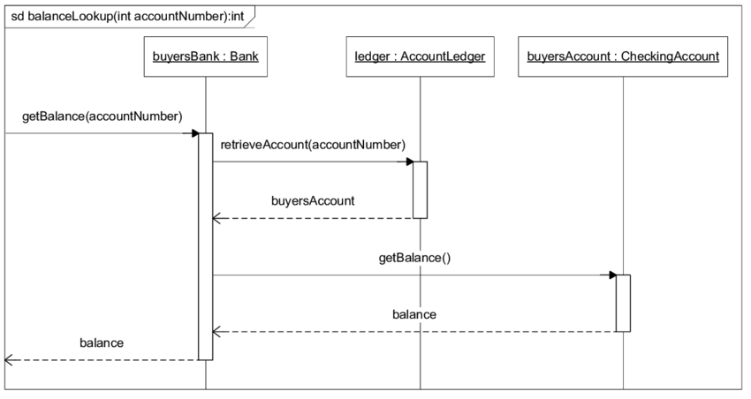

**Activity diagram to verify income:**

